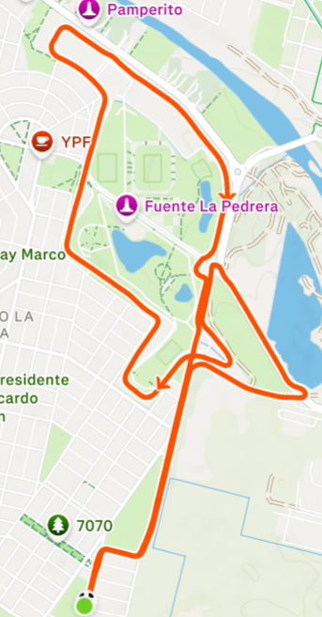
2
K
F
J
I
H
G
F
E
D
C
B
A
3
1

